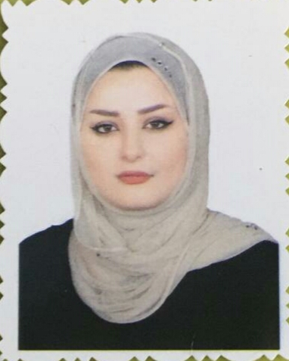

Farqan Ali Rasheed Alemara

Personal Information
Date of birth: Jan/23/1994

Nationality : Iraqi

Gender: Female

Address: Iraq/Baghdad

Phone Number: 00964 771663 1627

Email Address: foona.fofa94@yahoo.com

Education:
B.A Degree of College of Literature /Department of English

Work Experience
- Working in Asia cell Telecom.
2.working as an accountant in a private contracting Company.

Skills
Computer skills; Internet access, Social Media, Microsoft Office , and Typing.

Objectives
To seek a position that will enhance my professional, personal skills and financial status.

Hopefully, The information mentioned above are sufficient.

Thanks in advance

